Flemington Borough Police Explorer Post #49
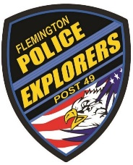
PERMISSION & CONSENT FORM
SOCIAL MEDIA, FACEBOOK
APPROVAL BY PARENT OR GUARDIAN

_____________________________________________
Explorer Name

___________________________________________________________________________________
Address City State Zip

_____________________________________________
Parent/Guardian Name

_____________________________
Parent/Guardian Phone Number

I, the parent/guardian of Explorer ________________________________, give permission for the Flemington Borough Police Explorer Post #49 to take pictures of my son or daughter for the purpose of posting on Social Media such as but not limited to Facebook. I understand that these pictures will be for public view and understand these pictures will be on the internet. I give full permission to Flemington Borough, Flemington Borough Police Department, Flemington Borough Police Explorer Post #49, including its Officers and Explorers to take pictures for the purpose of advertising the Flemington Borough Police Explorer Post #49. I understand that these pictures will still be online for public view after my son or daughter’s separation from the Flemington Borough Police Explorer Post #49.

_____________________________________________ _______________
Parent/Guardian Signature Date

